Project 1 – Static route 1

Ping from R1 to PC3
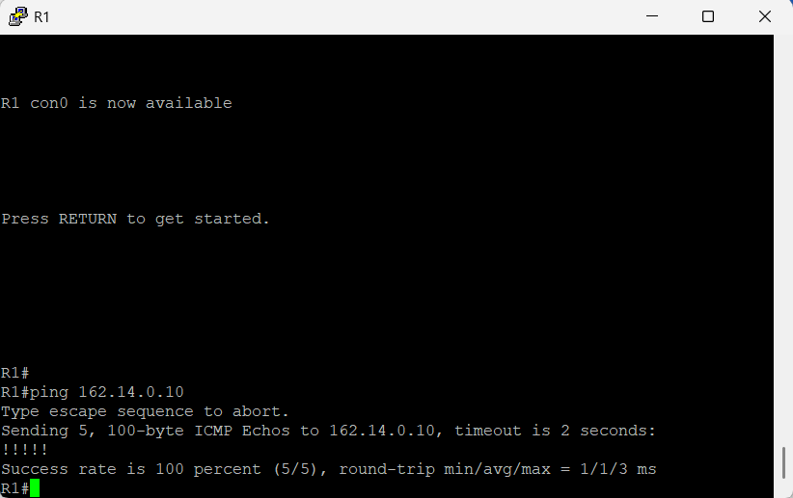

Ping from PC2 TO PC1

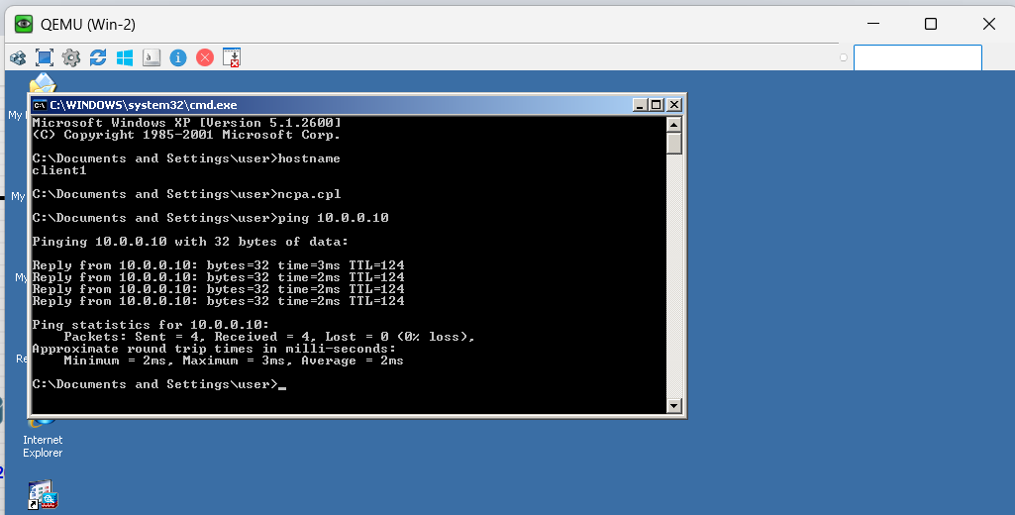

Ping from P2 TO P3

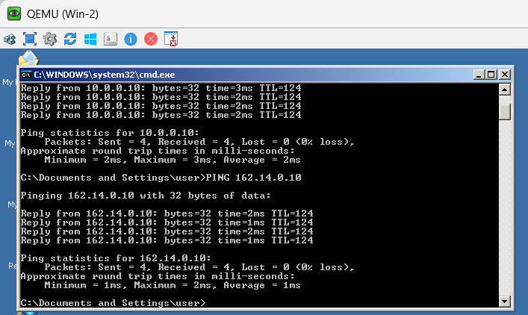

PING FROM PC1 TO PC2
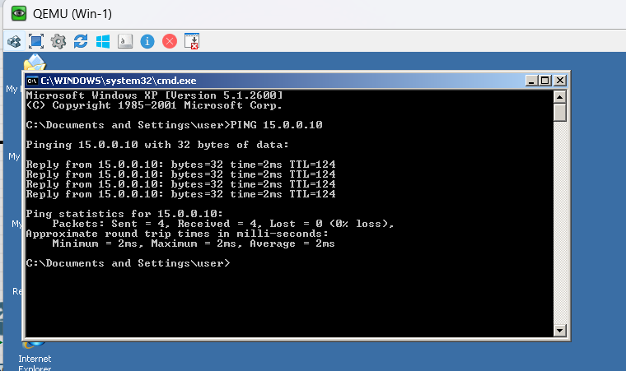

Ping from PC1 TO PC3

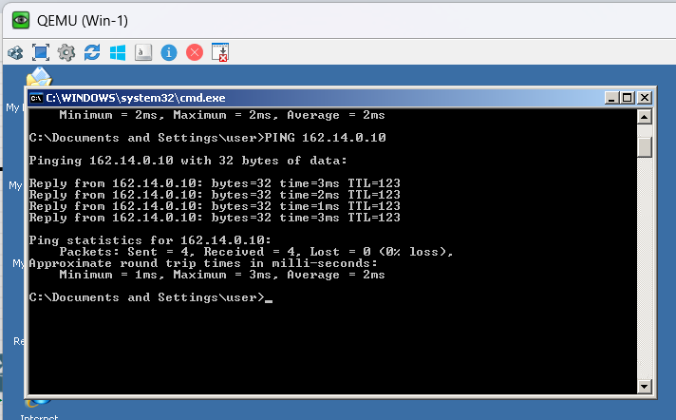

Ping from PC3 to PC1

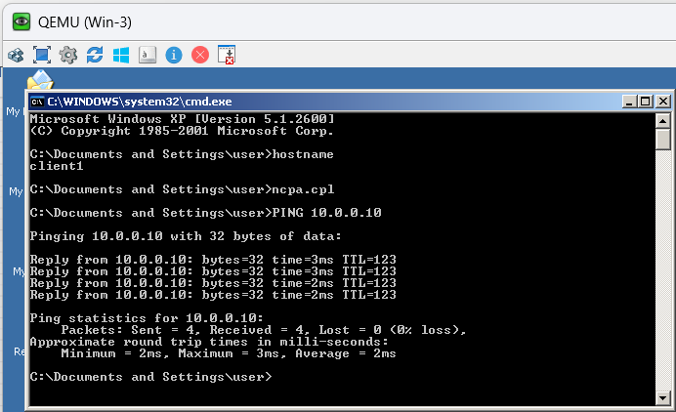

Ping from PC3 to PC2

